SOFTWARE REQUIREMENTS SPECIFICATION

CURRENCY EXCHANGE SIMULATION APP

Version: 1.0
Date:2025
Pages:18

Prepared by Abdumutalov Nodirjon

TABLE OF CONTENTS

INTRODUCTION 3
1. OVERALL DESCRIPTION 4
1.1. Document conventions 4
1.2. Project features 4
1.3. Operating Environment 5
Software Environment: 5
Storage Environment: 5
Hardware Requirements: 5
1.4. Design and Implementation Constraints 5
1.5. User Documentation 6
2. SYSTEM FEATURES 7
2.1. Conditional Description of Attribute Properties. 7
2.2. List of Web Service Methods Used During Interaction 8
2.3. Set Exchange Rates in Commercial 9
2.4. Get Best Exchange Rates 10
2.5. Get Bank Reference List 11
2.6. Get Currency Reference List 12
3. EXTERNAL INTERFACE REQUIREMENTS 13
3.1. User Interfaces 13
3.2. Software Interfaces 13
3.3. Hardware Interfaces 13
3.4. Communication Interfaces 13
4. NON FUNCTIONAL REQUIREMENTS 14
4.1. Performance Requirements 14
4.2. Safety Requirements 14
4.3. Software Quality Attributes 14
4.4. Security Requirements 14
OTHER REQUIREMENTS 15
APPENDIX A: GLOSSARY 16
APPENDIX B: ANALYSIS MODELS 17
B.1 Use Case Diagram 17
B.2 Data Flow Diagram (DFD) 17
B.3 UML Class Diagram 17
APPENDIX C: ISSUES LIST 18

INTRODUCTION
The purpose of this document is to define the functional and non-functional requirements of the “Currency Exchange Simulation App”, developed as part of the final project for the Object-Oriented Programming course.

The system is designed to help “individual users (physical persons)” find the most profitable currency exchange rates offered by various commercial banks in a fast, accessible, and user-friendly manner.

OVERALL DESCRIPTION

Document conventions
TERMS | DEFINITIONS
BANK (Commercial Bank) | Any bank participating in foreign exchange operations
IS | Information System
IS Currency App | Information system for managing and analyzing currency exchange operations
Interface | Boundary between two interacting systems/programs, defined by exchange methods and formats
Web Address | Symbolic sequence that identifies a physical or abstract resource
Web Service | Identifiable system with a standardized interface for data exchange over the web
REST | Architectural style for designing networked applications using standard HTTP methods
JSON | Text-based data exchange format, structured, described by RFC 8259
UTF-8 | Unicode Transformation Format, encoding standard defined in RFC 3629
MD5 | Algorithm for one-way hashing of text into a fixed-length 32-character hexadecimal string
Online Mode | Real-time processing mode
GraphQL | Query language for APIs and runtime for fulfilling those queries with existing data
USER | System participant who interacts with the API to get or set exchange data
DATABASE | Storage system where structured data is kept (in this app: JSON file)
VISITOR | Any external user accessing the system without modifying rights
STAKEHOLDER | Anyone with interest in the system: users, developers, reviewers
SRS | Software Requirements Specification — document describing system goals, requirements, and scope
SYSTEM (Client) | Computers used by users or banks to interact with the system
REDIS / MEMCACHED | Commonly used caching systems (not used in this simulation app, but may be used in future)

Project features

This section provides a high-level overview of the system's functionality. The detailed behavior of each feature is described later in Section 3 (System Features).
The DFD Level diagram below illustrates the general flow of data between external actors (users/banks) and internal system processes.
Data Flow Diagram
The diagram highlights how users interact with the system via the GraphQL API. It shows the processes for validating data, storing rates in JSON files, and retrieving optimal currency exchange information.
Main Functional Features:
1. Submit Exchange Rates (from Bank)
A commercial bank sends a mutation request (setRates) containing daily currency rates (buy/sell) for one or more currencies. The system validates the bank code and currency codes before writing to rates.json. If a record already exists for the given bank and date, it is updated.

2. Retrieve Exchange Rates (by User)
End users (individuals) can retrieve all available currency exchange rates, or filter them by specific bank and date (getAllRates, getRates). These queries allow insight into the current exchange market.

3. Best Rate Finder
A user can query the system for the best exchange rate for a specific currency (getBestRateByCurrency). The system processes all stored rates and returns sorted data by the most favorable buy and sell offers.

4. Validation Engine
During submission, the system checks the validity of:

- Bank code — matched against banks.json
- Currency code — matched against currencies.json
- Buy/Sell values — must be positive

5. Storage Layer (JSON-based)
Exchange data is stored in a structured format using three reference files:

banks.json — active bank list
currencies.json — list of ISO currency codes
rates.json — actual submitted exchange rates per bank and date

6. API Access via GraphQL
All interactions are performed through a GraphQL interface, allowing clients to send flexible queries and mutations to interact with the data.

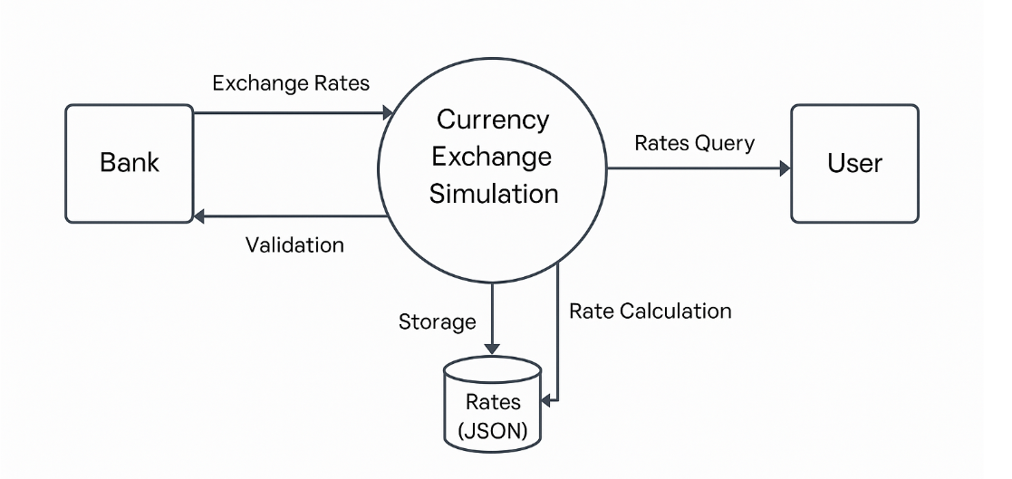

Operating Environment
The Currency Exchange Simulation App is designed to run in a local or lightweight server environment, using modern JavaScript/TypeScript tooling and Node.js. Since it uses temporary JSON files for data persistence, no external database is required at runtime.

Software Environment:
- Operating System:
  - Windows 10 / 11,
  - macOS 12+,
  - Ubuntu 20.04+ or any Linux distribution with Node.js support.

- Runtime Environment:
  - Node.js version 18.x or higher
  - TypeScript version 5.x
  - npm version 9.x (or compatible)

- Frameworks and Libraries:
  - NestJS (v10+) — Backend application framework
  - @nestjs/graphql — GraphQL module for API schema definition
  - Apollo Server — GraphQL query processor
  - fs/promises — For working with the file system (reading/writing JSON)
- API Playground:
  - GraphQL Playground — Local UI for testing queries and mutations, running on http://localhost:3000/graphql

Storage Environment:
- Data Persistence:
  - Exchange rate data is stored in plain .json files located in the /data/ directory.
  - Files used:
    - rates.json
    - banks.json
    - currencies.json

Hardware Requirements:
- Minimum RAM: 2 GB
- Disk Space: 100 MB (for Node modules and JSON files)
- Processor: Any dual-core CPU

Design and Implementation Constraints
The development and deployment of the Currency Exchange Simulation App are subject to the following constraints:
- Programming Language: The system is implemented entirely in TypeScript, using the NestJS framework. No other languages are allowed for core backend logic.
- Data Storage: The system uses file-based JSON storage as a temporary data source. Use of external databases (e.g., PostgreSQL, MongoDB) is not allowed in the current version due to project simplicity and scope.
- API Design Standards:
  - All interactions must follow the GraphQL schema defined in the system.
  - Only valid GraphQL-compliant queries and mutations are allowed.
- Data Format: All data exchanged within the system follows the JSON format using UTF-8 encoding. No XML or proprietary formats are supported.
- Browser Compatibility: The system is expected to be tested only in modern browsers that support GraphQL playground (e.g., Chrome, Firefox). Support for older browsers (e.g., Internet Explorer) is not guaranteed.
- Manual Input Assumption: Currency exchange data (rates) are assumed to be entered manually by users (e.g., banks). No external integration with APIs or scraping services is implemented or permitted.
- Business Logic Constraints:
  - Currency codes must follow the ISO 4217 standard (e.g., "W2X" for USD).
  - Each bank can submit only one exchange rate per currency per date.
  - All rate values must be positive floating-point numbers.
- Testing Constraints: Due to the absence of persistent storage or a frontend, all testing is conducted manually using GraphQL Playground.

User Documentation
The system includes the following user-facing documentation to assist in setup, usage, and interaction:
- README.md file in the GitHub repository, which provides:
  - Overview of the project purpose and functionality
  - Setup instructions (installation, running the server)
  - Sample GraphQL queries and mutations
  - Explanation of file structure and module roles
  - Technologies used and future improvements
- GraphQL Playground acts as an interactive user tool for exploring and testing the API. It provides:
  - Auto-completion and real-time feedback for queries
  - Schema introspection and documentation of available types, inputs, and responses
- SRS Document (this document) which provides:
  - Complete specification of system functionality
  - Functional and non-functional requirements
  - Glossary and external interface descriptions
No additional end-user manual or graphical UI help file is needed at this stage, as the application is backend-only and intended for technical users or evaluators familiar with GraphQL APIs

SYSTEM FEATURES

Conditional Description of Attribute Properties.
The description of attribute properties is provided in the following table:
Attribute | Code | Description
Mandatory | "M" | Defines whether the attribute must have a value
Mandatory | "M" | "+" | Mandatory – the attribute must always contain a value
Mandatory | "M" | "–" | Optional – the attribute may not contain a value
Mandatory | "M" | "±" | Conditional Mandatory – the attribute must contain a value under certain conditions
Value Type | "T" | Defines the type of value in the attribute
Value Type | "T" | Code | Description | Format
Value Type | "T" | "K" | Code
Value Type | "T" | "N" | Number
Value Type | "T" | "D" | Date | dd.mm.yyyy
Value Type | "T" | "L" | String
Value Type | "T" | "O" | Object | {key: value, …}
Value Type | "T" | "A" | Array | [item, item, …]
Size | "S" | Maximum length of the attribute value, ¶ for fractional numbers, precision can be specified after a comma, ¶ for arrays – maximum number of elements
Reference | "R" | Reference number – indicates the reference table on which the attribute is based

List of Web Service Methods Used During Interaction
№ | Method Name | Description | Frequency | Order of Use | Validation | GraphQL Name
1. | Set Exchange Rates in Commercial Banks | Commercial banks set currency exchange rates. The rates are valid until the next update by the same bank. Multiple rates (sell and buy) for several currencies can be submitted in a single request. | Any time | Any time | Bank code validation, currency code validation, positive values check | setRates
2. | Get Best Exchange Rates | Retrieves the most profitable buy and sell rates for a specific currency across all banks, sorted by profitability. | Any time | Any time | validation | getBestRateByCurrency
  Currency code
3. | Get Currency Reference List | Returns the list of all available currencies supported by the system. | Any time | Any time |  | getAllCurrencies
4. | Get Bank Reference List | Returns the list of all commercial banks supported by the system. | Any time | Any time |  | getAllBanks

Set Exchange Rates in Commercial

№ | Name | description | М | T | S | R
1. | Commercial Bank code | bank | + | K | 2 | 101
2. | Exchange rate date | rate_date | + | D | 10
2. | Rates Array | rates | + | A
2.0 | Array of rate entries | - | + | O
2.1 | Currency code | currency | + | K | 3 | 102
2.2 | Sell price | sell | + | F | 10,2
2.3 | Buy price | buy | + | F | 10,2

Example Request:
mutation {
setRates(
input: {
bank: "W55"
rate_date: "16.06.2025"
rates: [
{
currency: "X33"
buy: 12500.0
sell: 12700.0
},
{
currency: "D13"
buy: 13400.0
sell: 13600.0
}
]
}
)
}

Success Response:
{
"data": {
"setRates": true
}
}

Error example:
{
"errors": [
{
"message": "Invalid currency 'X33'",
}]
}

Get Best Exchange Rates

№ | name | description | М | T | S | R
1 | Currency code | currency | + | K | 3 | 102

Example Request:
query {
getBestRateByCurrency(currency: "X33") {
currency
result {
bank
buy
sell
currency
rate_date
}
}
}

Success Response:
{
"data": {
"getBestRateByCurrency": {
"currency": "X33",
"rate_date": "16.06.2025"
"result": [
{
"bank": "W55",
"buy": 12500,
"sell": 12700,
}
]
}
}
}

Error example:
{
"errors": [
{
"message": "Invalid currency 'X33'",
}]
}

Get Bank Reference List

Example Request:
query {
getAllBanks {
BANK_CODE
BANK_NAME
BANK_ACTIVE
}
}

Success Response:
{
"data": {
"getAllBanks": [
{
"BANK_CODE": "W55",
"BANK_NAME": "RICH BANK",
"BANK_ACTIVE": 1
},
{
"BANK_CODE": "3DD",
"BANK_NAME": "UPAY BANK",
"BANK_ACTIVE": 1
},
{
"BANK_CODE": "004",
"BANK_NAME": "ZOOM BANK",
"BANK_ACTIVE": 1
},
{
"BANK_CODE": "BE5",
"BANK_NAME": "GREEDY BANK",
"BANK_ACTIVE": 1
},
{
"BANK_CODE": "A26",
"BANK_NAME": "KOREA BANK",
"BANK_ACTIVE": 1
}
]
}
}

Get Currency Reference List

Example Request
query {
getAllCurrencies {
currency_code
currency_name
character
}
}

Success Response:
{
"data": {
" getAllCurrencies ": [
{
"CURRENCY_CODE": "W55",
"CHARACTER": "USD"
},
{
"CURRENCY_CODE": "22A",
" CHARACTER ": "EUR",
},
]
}
}

EXTERNAL INTERFACE REQUIREMENTS

User Interfaces
- The application exposes a GraphQL Playground for testing queries and mutations.
- URL: http://localhost:3000/graphql
- No graphical user interface (GUI) is implemented yet.

Software Interfaces
- GraphQL API (Apollo Server, @nestjs/graphql)
- Node.js File System Module (fs/promises)
- JSON file-based storage (rates.json, banks.json, currencies.json)

Hardware Interfaces
- The system interacts with the host file system for read/write operations.
- No hardware peripherals are used.

Communication Interfaces
- Communication is handled through HTTP POST requests to the GraphQL endpoint.
- The app does not support WebSockets or REST API.

NON FUNCTIONAL REQUIREMENTS

Performance Requirements
- All requests must complete within 1 second for data sizes under 100 records.
- File operations should not block event loop.

Safety Requirements
- Rate input validation is performed before saving data.
- File writing includes pre-checks for corruption or invalid format.

Software Quality Attributes
- Modular Structure: Divided into domain modules (rate, bank, currency).
- Testability: Endpoints can be manually tested through GraphQL Playground.
- Maintainability: Source code follows TypeScript and NestJS conventions.
- Reusability: DTOs and models are independent and reusable.

Security Requirements
- Only valid bank/currency codes are accepted.
- JSON file path is restricted to /data directory to prevent access to other files.
- No authentication/authorization is implemented.

OTHER REQUIREMENTS

- The app is designed for educational/demo use.
- Future versions may include authentication, history tracking, or frontend.
- No support for concurrent writes or multi-user sessions is provided.

APPENDIX A: GLOSSARY

Term | Definition
Bank Code | 3-digit string uniquely identifying a bank (e.g., "002")
Currency Code | 3-digit ISO 4217 code (e.g., 840 = USD, 978 = EUR)
Buy Rate | Rate at which a bank buys foreign currency from the user
Sell Rate | Rate at which a bank sells foreign currency to the user
GraphQL | A query language for APIs used to request structured data
JSON | Lightweight format for storing and exchanging data (used for file storage)
DTO (Data Transfer Object) | Object used to transfer structured data between layers
Resolver | GraphQL component responsible for processing incoming queries/mutations
Mutation | A GraphQL operation that modifies data (e.g., setting rates)
Query | A GraphQL operation that fetches data
Playground | Web interface to test GraphQL APIs
Exchange Rate | Financial metric that determines the value of one currency in terms of another
Rate Date | Date on which the exchange rate is valid

APPENDIX B: ANALYSIS MODELS
This section presents the analysis models used to describe the system’s architecture and behavior. These include the Use Case Diagram, Data Flow Diagrams (DFD), and UML Class Diagram.

B.1 Use Case Diagram
This diagram shows the main interactions between external actors and the system:
Actors:
- Bank: submits exchange rates
- User: queries for best rates and reference data
Use Cases:
- Submit exchange rates
- Get best exchange rate
- Get all exchange rates
- Get bank/currency reference lists

B.2 Data Flow Diagram (DFD)
Level 0:
- Shows how data flows between the user, banks, and storage.
- Highlights main operations: validate input → store/retrieve JSON data → respond via GraphQL.
Level 1:
- Explodes rate-setting process into:
  - Validate bank, currency, and rate values
  - Check for duplicates
  - Save or update record in rates.json

B.3 UML Class Diagram
The class diagram below illustrates the logical structure of the system:
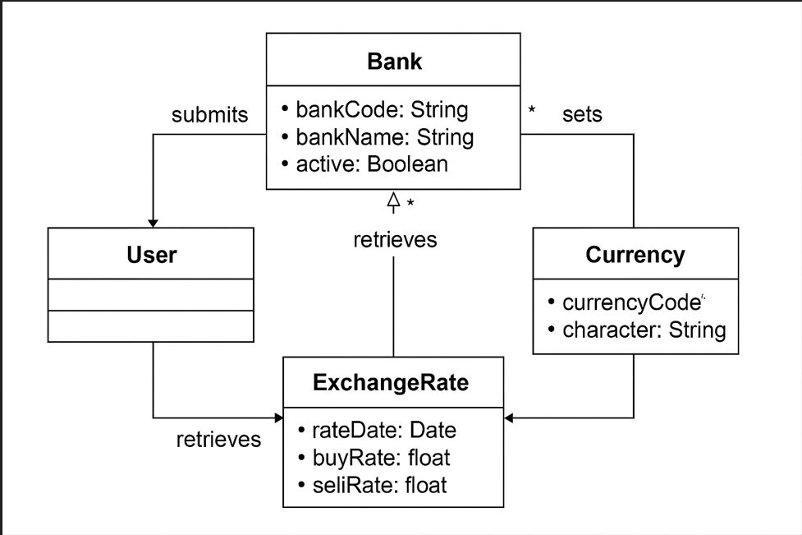
Key classes and relationships:
- Bank
  - bankCode: String
  - bankName: String
  - active: Boolean
- Currency
  - currencyCode: String
  - character: String
- ExchangeRate
  - rateDate: Date
  - buyRate: float
  - sellRate: float
- User
  - Initiates queries for retrieving exchange rates and references.
Relationships:
- Banks submit exchange rates.
- Exchange rates are linked to banks and currencies.
- Users retrieve exchange rate data and reference information.

APPENDIX C: ISSUES LIST

№ | Issue | Status
1 | Add persistent database (PostgreSQL / MongoDB) | Planned
2 | Implement frontend UI using React + Apollo Client | Planned
3 | Add unit and integration tests for service and resolver layers | Pending
4 | Improve error handling and logging | In Progress
5 | Support conversion between currencies (e.g., USD → EUR) | Planned
6 | Support multiple users with concurrent safe file access | Not Started
7 | Add pagination, filtering options to getAllRates | Not Started
8 | Enforce date format validation and duplicate prevention | In Progress
9 | Archive historical exchange rates (rate history feature) | Planned
10 | Add internationalization (i18n) support for currency symbols and names | Not Started

